2024
M. R. Das, K. Behera, C. Moharana
Students, Department of ECE, ABIT, Cuttack
8/5/2024
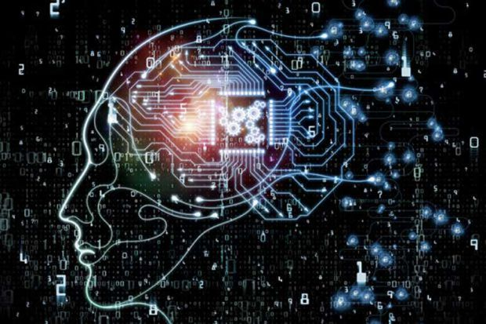
An NCS using ANN & Deep Learning

Artificial Neurons:

Introduction
Artificial neurons are the fundamental building blocks of artificial neural networks (ANNs), designed to mimic the functionality of biological neurons. These computational units enable machines to learn from data, make predictions, and perform complex tasks. This report delves into the definition, history, classification, construction, structural details, applications, and future prospects of artificial neurons.

Definition of Artificial Neurons
Artificial neurons are simplified models of biological neurons, which form the basis of artificial neural networks. Each artificial neuron takes multiple inputs, processes them through a weighted sum, adds a bias, and applies an activation function to produce an output. This output is then used as an input to other neurons or as a final prediction.
Mathematically, an artificial neuron can be represented as:


History of Artificial Neurons

Early Concepts and Theoretical Foundations
- 1943: McCulloch-Pitts Neuron:
  - Warren McCulloch and Walter Pitts proposed the first mathematical model of a biological neuron. This model used binary inputs and outputs, laying the groundwork for neural network research by demonstrating that networks of such neurons could compute logical functions.
- 1958: Perceptron:
  - Frank Rosenblatt introduced the perceptron, an early type of artificial neural network capable of learning. The perceptron consists of a single layer of artificial neurons and uses a simple learning algorithm to adjust weights based on errors in predictions. It was limited to solving linearly separable problems but marked a significant step forward in machine learning.

Development of Neural Network Architectures
- 1960s-1970s: Multilayer Perceptron (MLP):
  - Researchers began exploring neural networks with multiple layers, known as multilayer perceptrons (MLPs). The lack of an efficient learning algorithm for hidden layers limited their practical use.
- 1986: Backpropagation Algorithm:
  - David Rumelhart, Geoffrey Hinton, and Ronald Williams developed the backpropagation algorithm, enabling the training of MLPs. Backpropagation uses gradient descent to minimize error by adjusting weights and biases, making deep learning feasible and revitalizing interest in neural networks.

Advancements and Modern Developments
- 1990s: Convolutional Neural Networks (CNNs):
  - Yann LeCun and colleagues introduced CNNs for image recognition tasks. CNNs utilize convolutional layers to extract spatial hierarchies and patterns, significantly improving performance in computer vision applications.
- 2000s: Recurrent Neural Networks (RNNs) and Long Short-Term Memory (LSTM):
  - RNNs, designed for sequential data, gained attention. Standard RNNs struggled with long-term dependencies due to vanishing gradients. LSTM networks, introduced by Sepp Hochreiter and Jürgen Schmidhuber, addressed this issue, enabling the modeling of long-term dependencies in sequence data.
- 2010s: Deep Learning and Transformers:
  - The resurgence of deep learning, fueled by increased computational power and large datasets, led to significant advancements. Deep neural networks, particularly deep CNNs, achieved state-of-the-art performance in various tasks.
  - The introduction of the Transformer architecture by Vaswani et al. in 2017 revolutionized natural language processing, forming the foundation for powerful language models like BERT and GPT.

Recent Trends and Innovations
- Generative Models:
  - Generative Adversarial Networks (GANs), introduced by Ian Goodfellow in 2014, enabled the creation of realistic images, music, and more.
- Reinforcement Learning:
  - Combining neural networks with reinforcement learning has led to breakthroughs in decision-making tasks, exemplified by AlphaGo, which defeated human champions in the game of Go.

Classification of Artificial Neurons
Artificial neurons can be classified based on their role, architecture, and the type of activation function used:

Based on Structure
- Single-Layer Perceptron:
  - A neural network with a single layer of artificial neurons, often used for simple classification tasks. Each neuron in the layer outputs a class label or a continuous value.
- Multi-Layer Perceptron (MLP):
  - A neural network with one or more hidden layers between the input and output layers. MLPs are used for complex tasks requiring multiple layers of abstraction.

Based on Role in Neural Network
- Input Neurons:
  - These neurons receive initial data inputs and pass them to the next layer without performing any significant computations.
- Hidden Neurons:
  - Located in hidden layers, these neurons process inputs received from the previous layer. They perform significant computations to extract features and patterns from the data.
- Output Neurons:
  - These neurons produce the final output of the neural network. The number of output neurons depends on the nature of the task (e.g., classification, regression).

Based on Network Architecture
- Feedforward Neurons:
  - Neurons in feedforward neural networks, where connections between neurons do not form cycles. Information flows in one direction from input to output.
- Recurrent Neurons:
  - Neurons in recurrent neural networks (RNNs) where connections form cycles, allowing the network to maintain memory of previous inputs and capture temporal dependencies.
- Convolutional Neurons:
  - Specialized neurons used in convolutional neural networks (CNNs) for processing grid-like data (e.g., images). They apply convolutional operations to extract spatial features.

Based on Activation Function
- Binary Neurons:
  - Use binary activation functions such as the step function, which produces outputs of either 0 or 1 based on whether the weighted sum exceeds a threshold.
- Continuous Neurons:
  - Utilize continuous activation functions such as sigmoid or hyperbolic tangent (tanh), which produce outputs in a continuous range.
- Rectified Neurons:
  - Employ ReLU (Rectified Linear Unit) activation functions, which output the input directly if it is positive, or zero otherwise. This function helps in addressing vanishing gradient issues in deep networks.
- Linear Neurons:
  - Use a linear activation function, typically used in the output layer for regression tasks.
- Non-linear Neurons:
  - Use non-linear activation functions to introduce non-linearity into the network. Common non-linear activation functions include:
    - Sigmoid Neurons:
    - 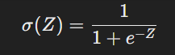
    - Tanh Neurons:
    - 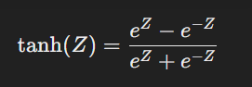
    - ReLU Neurons:
    - 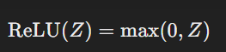
    - Leaky ReLU Neurons:
    - 

Construction and Structural Details of Artificial Neurons

Detailed Components and Their Roles
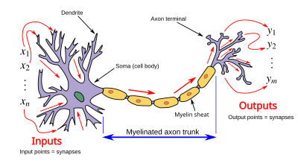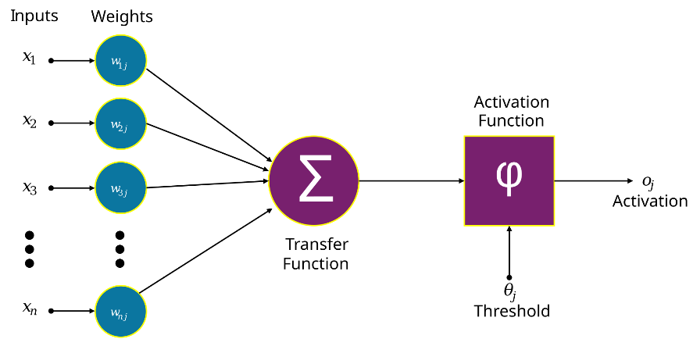
- Inputs (Features):
  - Inputs are the initial data fed into the neuron, which could be raw data points, extracted features, or outputs from preceding layers in the network.

- Weights:
  - Weights represent the strength of the connection between an input and the neuron. Each input is multiplied by its corresponding weight during computation. Weights are initialized (usually randomly or with specific techniques) and adjusted during training to minimize error.
- Bias:
  - The bias is an additional parameter added to the weighted sum of the inputs, providing flexibility in fitting the data. Like weights, biases are learned during training.
- Summation Function:
  - This function calculates the weighted sum of the inputs plus the bias:
  - 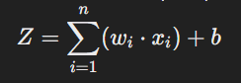
  - It integrates all input signals into a single scalar value, preparing it for the activation function.
- Activation Function:
  - The activation function introduces non-linearity, enabling the network to model complex relationships. Common activation functions include:
    - Sigmoid:
    - 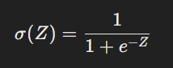
    - Hyperbolic Tangent (tanh):
    - 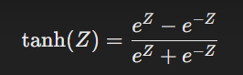
    - Rectified Linear Unit (ReLU):
    - 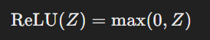

- Output:
  - The output of the neuron is the result of the activation function applied to the weighted sum. This output can be used as an input to subsequent neurons or as a final prediction.

Mathematical Representation
The entire process can be represented mathematically as follows:
- Weighted Sum Calculation:
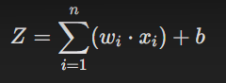
- Activation:


Training Process and Weight Adjustment
The training process involves updating weights and biases to minimize the error between predicted and actual outputs, typically using backpropagation and gradient descent.
- Forward Propagation:
  - Inputs are passed through the network layer by layer, with each neuron performing computations and passing results to the next layer.
- Loss Calculation:
  - The loss function measures the difference between predicted and actual outputs. Common loss functions include mean squared error (MSE) for regression and cross-entropy loss for classification.
- Backpropagation:
  - The error is propagated backward, calculating gradients of the loss with respect to each weight and bias using the chain rule.
- Weight and Bias Update:
  - 
  - where η is the learning rate and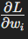 is the gradient of the loss with respect to the weight.

Structural Design in Neural Networks
The human brain is the inspiration behind neural network architecture. Human brain cells, called neurons, form a complex, highly interconnected network and send electrical signals to each other to help humans process information. Similarly, an artificial neural network is made of artificial neurons that work together to solve a problem. Artificial neurons are software modules, called nodes, and artificial neural networks are software programs or algorithms that, at their core, use computing systems to solve mathematical calculations.
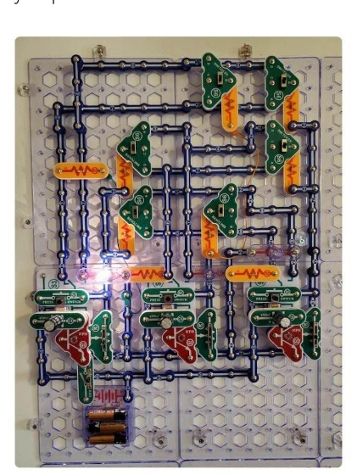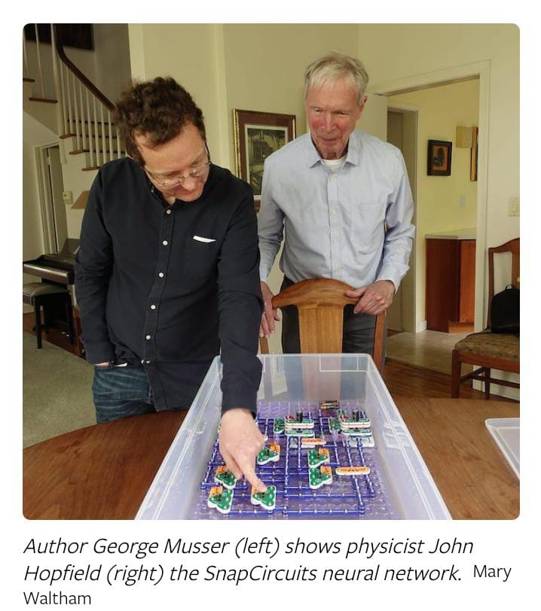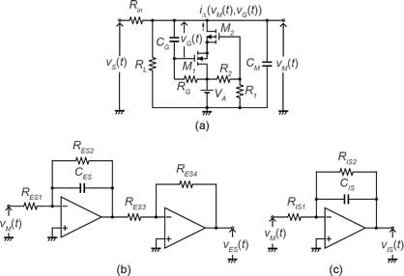
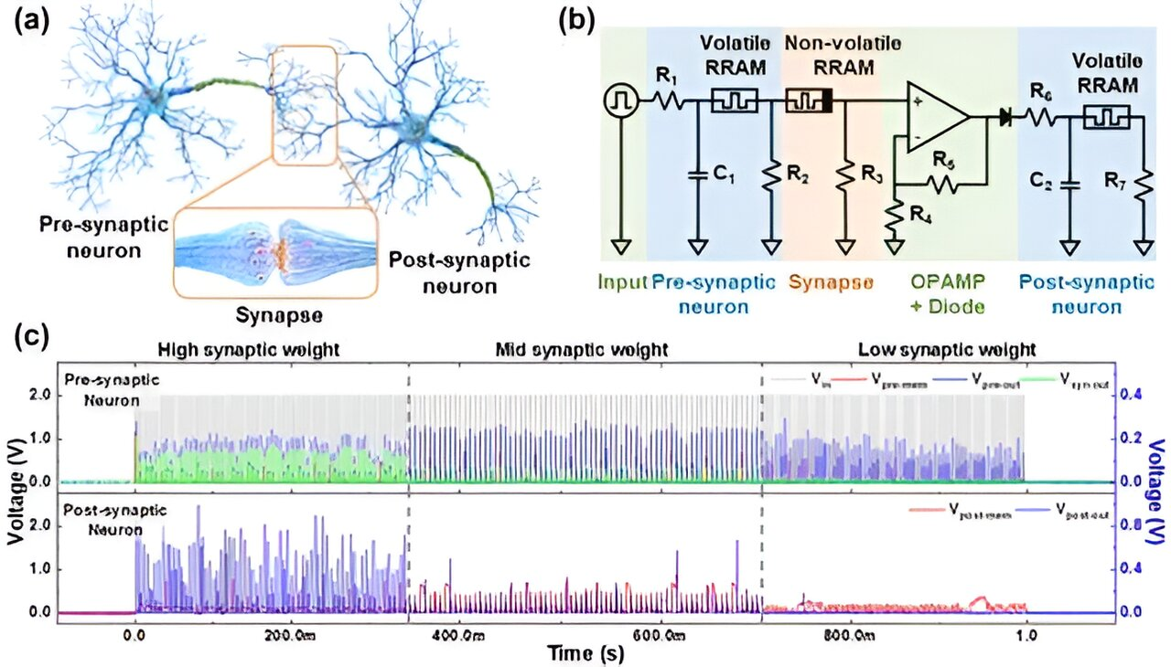
Figure (a): Pre-synaptic and Post-synaptic Neurons
- Pre-synaptic Neuron: This is the neuron that sends the signal.
- Post-synaptic Neuron: This is the neuron that receives the signal.
- Synaptic Weight: This represents the strength of the connection between the two neurons. In biological terms, it’s the efficiency of the synapse in transmitting signals.
Figure (b): Synapse Circuit Diagram
- This part shows an electronic equivalent of a biological synapse.
- Components:
  - Resistors ®: These control the flow of current.
  - Capacitors ©: These store and release electrical energy.
  - Operational Amplifiers (OpAMP): These amplify the electrical signals.
  - RRAM (Resistive Random-Access Memory): This is used to mimic the synaptic weight, which can change based on the input signals.
- The circuit diagram illustrates how these components work together to simulate the behavior of a biological synapse.
Figure ©: Synaptic Weight Changes
- Graphs: These show how the synaptic weights change over time.
  - Top Graph: Displays the spikes from the pre-synaptic neuron in blue.
  - Bottom Graph: Shows the spikes from the post-synaptic neuron in purple.
- Voltage (V) vs. Time (s): The y-axis represents the voltage, and the x-axis represents time.
- These graphs help visualize how the synaptic weights are adjusted based on the activity of the neurons.
This image demonstrates how electronic components can be used to replicate the functions of biological neurons and synapses, which is essential for developing neuromorphic computing systems.

Simple neural network architecture:
A basic neural network has interconnected artificial neurons in three layers:
- Input Layer:
  - The first layer receives input features. Neurons in this layer do not perform any computation other than passing data to the next layer.
- Hidden Layers:
  - One or more intermediate layers where computations are performed. Neurons in hidden layers receive inputs from the previous layer, process them, and pass outputs to the next layer. These layers enable the network to learn complex representations.
- Output Layer:
  - The final layer produces the output predictions. The number of neurons in this layer corresponds to the number of output variables.

Types of Neural Networks
Different types of neural networks use artificial neurons in various configurations for specific tasks:
- Feedforward Neural Networks (FNNs):
  - Information flows in one direction from input to output layer. Used for tasks like image classification and regression.
- Convolutional Neural Networks (CNNs):
  - Specialized for processing grid-like data such as images. They use convolutional layers to extract spatial hierarchies and patterns.
- Recurrent Neural Networks (RNNs):
  - Designed for sequential data processing, such as time series analysis and natural language processing. They have loops that allow information to persist, capturing temporal dependencies.
- Transformers:
  - Advanced models for sequence-to-sequence tasks, especially in NLP. They rely on self-attention mechanisms to process sequences in parallel, leading to significant improvements in tasks like language translation.

Applications of Artificial Neurons
Artificial Neurons and Artificial Neural Networks have diverse applications across various fields. This section explores detailed applications in computer vision, natural language processing, healthcare, and other emerging areas.

Computer Vision Projects

1. Autonomous Vehicles
Procedure & Methodology:
- Data Collection: Gather large datasets of labeled images and sensor data (e.g., LiDAR, radar).
- Preprocessing: Normalize images, augment data to increase variety, and segment images to identify objects.
- Model Design: Use CNNs to build models for object detection, lane detection, and traffic sign recognition.
- Training: Train the model using supervised learning with labeled datasets. Use backpropagation and gradient descent to adjust weights.
- Validation & Testing: Validate the model on a separate dataset and test it in real-world conditions.
- Deployment: Implement the trained model into the vehicle's perception system for real-time decision-making.
- Perception Systems:
  - Object Detection and Classification:
    - CNNs are employed to develop perception systems for self-driving cars. These systems detect and classify objects, such as other vehicles, pedestrians, and road signs, in real-time.
    - Example: Tesla’s Autopilot and Waymo's self-driving technology utilize CNNs to process visual data from cameras, lidar, and radar sensors to make driving decisions.
  - Lane Detection:
    - Neural networks identify and track lane markings on the road to assist with lane keeping and lane changing maneuvers.
    - Example: NVIDIA's Drive PX platform uses deep learning for lane detection and road segmentation.
- Obstacle Avoidance and Path Planning:
  - Real-Time Navigation:
    - Neural networks predict safe paths by analyzing sensor data and avoiding obstacles. This is crucial for ensuring the safety of autonomous vehicles.
    - Example: Mobileye's self-driving technology incorporates neural networks for real-time path planning and obstacle avoidance.

2. Medical Imaging
Procedure & Methodology:
- Data Collection: Obtain medical images (e.g., X-rays, CT scans, MRIs) from hospitals and medical institutions.
- Preprocessing: Enhance image quality, normalize pixel values, and segment regions of interest.
- Model Design: Develop CNN architectures for image classification, segmentation, and anomaly detection.
- Training: Train the model on annotated medical images using supervised learning. Utilize data augmentation to increase dataset diversity.
- Validation & Testing: Validate the model using cross-validation techniques and test it on new datasets.
- Deployment: Integrate the model into clinical workflows for assisting radiologists and healthcare providers.
- Diagnostic Tools:
  - Tumor Detection:
    - Deep learning models analyze medical images (e.g., X-rays, MRIs) to detect tumors with high accuracy, assisting radiologists in diagnosing conditions early.
    - Example: Google's DeepMind developed an AI system that can detect over 50 eye diseases by analyzing retinal scans.
  - Segmentation and Classification:
    - Neural networks perform segmentation to identify and classify different anatomical structures and abnormalities in medical images.
    - Example: U-Net, a CNN architecture, is widely used for medical image segmentation tasks.
- Predictive Analysis:
  - Prognosis and Treatment Planning:
    - Neural networks predict disease progression and outcomes based on medical imaging and patient data, aiding in personalized treatment planning.
    - Example: IBM Watson Health uses AI to analyze medical images and patient records to provide insights for oncology treatment.

3. Smart Surveillance Systems
Procedure & Methodology:
- Data Collection: Collect surveillance footage from cameras placed in various locations.
- Preprocessing: Resize and normalize video frames, and annotate objects of interest.
- Model Design: Create CNN-based models for object detection, facial recognition, and behavior analysis.
- Training: Train the models using labeled video frames. Employ techniques like transfer learning to enhance performance.
- Validation & Testing: Validate the models on separate datasets and test them in real-world surveillance scenarios.
- Deployment: Implement the models in surveillance systems for real-time monitoring and alerting.
- Real-time Object Detection:
  - Facial Recognition:
    - Intelligent surveillance systems use neural networks for facial recognition to identify individuals in real-time, enhancing security and monitoring.
    - Example: Face recognition technology is deployed in airports and public places for security checks and access control.
  - Anomaly Detection:
    - Neural networks detect unusual or suspicious activities in surveillance footage, alerting security personnel to potential threats.
    - Example: Hikvision's AI-powered cameras use deep learning for real-time anomaly detection in crowded environments.

- Crowd Management:
  - Behavior Analysis:
    - Neural networks analyze crowd behavior to identify patterns and detect potential hazards or emergencies.
    - Example: AI-based crowd management systems are used in stadiums and public events to ensure safety and manage large gatherings.

Natural Language Processing (NLP) Projects

1. Chatbots and Virtual Assistants
Procedure & Methodology:
- Data Collection: Collect conversational data from customer service logs, chat transcripts, and other sources.
- Preprocessing: Tokenize text, remove stop words, and normalize text (e.g., lowercasing, stemming).
- Model Design: Use transformer architectures (e.g., GPT, BERT) for understanding and generating human language.
- Training: Train the model on large conversational datasets using supervised learning. Fine-tune the model on specific tasks.
- Validation & Testing: Validate the model using dialogue datasets and test it in simulated conversations.
- Deployment: Integrate the model into chat interfaces for customer support and virtual assistance.
- Conversational Agents:
  - Customer Support:
    - Transformers, such as BERT and GPT, power chatbots that provide customer support by answering queries and resolving issues.
    - Example: Bank of America's Erica and Google's Dialogflow are used to develop advanced conversational agents for various industries.
  - Task Automation:
    - Virtual assistants automate routine tasks, such as scheduling appointments, setting reminders, and managing emails.
    - Example: Apple's Siri, Amazon's Alexa, and Microsoft's Cortana are popular virtual assistants that use neural networks for natural language understanding and task automation.
- Language Understanding:
  - Intent Recognition:
    - Neural networks identify user intent from text or voice input to provide accurate responses and perform appropriate actions.
    - Example: AI-powered customer service bots can understand and process natural language queries, improving customer experience.

2. Language Translation
Procedure & Methodology:
- Data Collection: Gather parallel corpora (e.g., translated texts) in multiple languages.
- Preprocessing: Tokenize text, align parallel sentences, and clean data.
- Model Design: Develop transformer-based models for sequence-to-sequence translation tasks.
- Training: Train the model on large bilingual datasets using supervised learning. Fine-tune on specific language pairs.
- Validation & Testing: Validate the model using bilingual evaluation benchmarks and test on unseen text.
- Deployment: Implement the model in translation services and applications for real-time translation.
- Advanced Translation Models:
  - Neural Machine Translation (NMT):
    - Neural networks, particularly transformers, are used in language translation models to provide high accuracy and fluency in multiple languages.
    - Example: Google Translate and Microsoft Translator leverage NMT models to translate text and speech between various languages.
  - Contextual Understanding:
    - Neural networks understand context and nuances in language, improving the quality and coherence of translations.
    - Example: Facebook's M2M-100 is a multilingual model that can translate between any pair of 100 languages without relying on English as an intermediary.
- Real-Time Translation:
  - Speech-to-Text and Text-to-Speech:
    - Neural networks enable real-time translation of spoken language, converting speech to text and translating it into another language.
    - Example: Skype Translator uses neural networks to provide real-time voice translation during video calls.

3. Text Summarization
Procedure & Methodology:
- Data Collection: Collect large corpora of text documents and their summaries.
- Preprocessing: Tokenize text, clean data, and align documents with their summaries.
- Model Design: Use transformer architectures for extractive and abstractive summarization.
- Training: Train the model on document-summary pairs using supervised learning. Fine-tune on specific domains (e.g., news, scientific papers).
- Validation & Testing: Validate the model using summarization benchmarks and test on new documents.
- Deployment: Integrate the model into content management systems for automatic summarization.
- Automatic Summarization Tools:
  - Extractive Summarization:
    - Neural networks select key sentences or phrases from a document to create a concise summary.
    - Example: Sumy and Gensim are Python libraries that use neural networks for extractive text summarization.
  - Abstractive Summarization:
    - Neural networks generate new sentences that capture the main ideas of the original text, creating a more coherent and readable summary.
    - Example: OpenAI's GPT models are used for abstractive summarization, producing human-like summaries of long articles and reports.
- Document Analysis:
  - Content Extraction:
    - Neural networks extract relevant information from large volumes of text, making it easier to analyze and understand.
    - Example: AI-powered tools for legal and financial document analysis can summarize key points and identify important clauses.

Healthcare Projects

1. Predictive Analytics for Patient Care
Procedure & Methodology:
- Data Collection: Gather electronic health records (EHRs) and clinical data from healthcare providers.
- Preprocessing: Clean and standardize data, handle missing values, and encode categorical variables.
- Model Design: Develop neural network models (e.g., MLPs, RNNs) for predicting patient outcomes.
- Training: Train the model on historical patient data using supervised learning. Use techniques like cross-validation to ensure robustness.
- Validation & Testing: Validate the model using patient outcome benchmarks and test on new patient data.
- Deployment: Implement the model in clinical decision support systems for real-time risk assessment.
- Outcome Prediction:
  - Readmission Risk:
    - Neural networks analyze patient data to predict the risk of hospital readmission, enabling proactive interventions.
    - Example: LACE index prediction models use deep learning to assess the likelihood of patient readmission within 30 days.
  - Disease Progression:
    - Neural networks predict the progression of chronic diseases, such as diabetes and heart disease, by analyzing patient health records.
    - Example: AI models used in chronic disease management programs provide personalized recommendations for lifestyle and treatment adjustments.
- Treatment Optimization:
  - Personalized Treatment Plans:
    - Neural networks recommend optimal treatment plans based on individual patient characteristics and historical data.
    - Example: IBM Watson for Oncology uses AI to suggest evidence-based treatment options for cancer patients, tailored to their specific needs.

2. Drug Discovery
Procedure & Methodology:
- Data Collection: Collect chemical compound data and biological activity assays from public databases.
- Preprocessing: Normalize chemical structures, encode molecular features, and handle missing values.
- Model Design: Use neural network models (e.g., graph neural networks, CNNs) for predicting compound properties and activities.
- Training: Train the model on labeled datasets using supervised learning. Use techniques like transfer learning to improve performance.
- Validation & Testing: Validate the model using drug discovery benchmarks and test on new compounds.
- Deployment: Integrate the model into drug discovery pipelines for virtual screening and lead optimization.
- Chemical Compound Analysis:
  - Predicting Drug Efficacy:
    - Neural networks analyze chemical structures and predict the potential efficacy of new drug compounds, accelerating the drug discovery process.
    - Example: Atomwise's AI platform uses deep learning to identify promising drug candidates by analyzing molecular structures.
  - Toxicity Prediction:
    - Neural networks predict the toxicity of chemical compounds, reducing the risk of adverse effects in drug development.
    - Example: DeepChem is an open-source library that uses neural networks for predictive modeling in drug discovery and materials science.
- Virtual Screening:
  - High-Throughput Screening:
    - Neural networks perform virtual screening of large libraries of compounds to identify potential drug candidates.
    - Example: Schrödinger's computational drug discovery platform uses deep learning for virtual screening and molecular docking simulations.

3. Personalized Medicine
Procedure & Methodology:
- Data Collection: Gather genomic data, clinical records, and treatment outcomes from patients.
- Preprocessing: Normalize genomic sequences, encode genetic variants, and clean clinical data.
- Model Design: Develop neural network models (e.g., CNNs, RNNs) for predicting personalized treatment responses.
- Training: Train the model on patient data using supervised learning. Fine-tune on specific medical conditions.
- Validation & Testing: Validate the model using personalized medicine benchmarks and test on new patient data.
- Deployment: Implement the model in clinical decision support systems for personalized treatment recommendations.
- Tailored Treatments:
  - Genomic Analysis:
    - Neural networks analyze genomic data to predict individual responses to different treatments, enabling personalized medicine.
    - Example: Tempus uses AI to analyze genomic and clinical data, providing oncologists with insights for personalized cancer treatment plans.
  - Precision Oncology:
    - Neural networks identify biomarkers and genetic mutations associated with specific cancers, guiding targeted therapies.
    - Example: Foundation Medicine's AI-driven platform analyzes tumor genomics to recommend precision oncology treatments.
- Patient Monitoring:
  - Remote Health Monitoring:
    - Neural networks analyze data from wearable devices and sensors to monitor patient health in real-time, enabling early intervention.
    - Example: Fitbit and Apple Watch use AI to track vital signs and detect anomalies, providing alerts for potential health issues.

Emerging Applications and Future Prospects

1. Neurosymbolic AI
- Combining Neural Networks with Symbolic Reasoning:
  - Hybrid Models:
    - Neurosymbolic AI integrates neural networks with symbolic reasoning to enhance interpretability and leverage structured knowledge.
    - Example: IBM's Project Debater combines neural networks with symbolic AI to understand and generate human-like arguments in debates.
- Knowledge Representation:
  - Structured Data Integration:
    - Neurosymbolic AI systems use structured knowledge bases to improve decision-making and reasoning.
    - Example: AI models that integrate knowledge graphs, such as Google's Knowledge Graph, enhance search and recommendation systems.

2. Few-Shot Learning
- Learning from Limited Data:
  - Meta-Learning:
    - Few-shot learning models use meta-learning techniques to quickly adapt to new tasks with minimal data.
    - Example: Google's Model-Agnostic Meta-Learning (MAML) framework enables AI systems to learn new tasks from just a few examples.
  - Transfer Learning:
    - Pretrained neural networks transfer knowledge from large datasets to new tasks, improving performance with limited data.
    - Example: OpenAI's GPT-3 model uses transfer learning to perform various NLP tasks with few-shot or zero-shot capabilities.
- Applications:
  - Personalized Recommendations:
    - Few-shot learning improves personalized recommendations in scenarios with limited user data, such as new users on e-commerce platforms.
    - Example: Netflix's recommendation system uses few-shot learning to suggest content to new subscribers based on minimal viewing history.

3. Explainable AI (XAI)
- Improving Transparency:
  - Interpretability Techniques:
    - Explainable AI focuses on developing techniques to make neural network decisions more transparent and understandable.
    - Example: LIME (Local Interpretable Model-agnostic Explanations) and SHAP (SHapley Additive exPlanations) are tools used to explain AI model predictions.
  - Ethical AI Use:
    - Ensuring ethical AI use by making decision-making processes transparent, particularly in sensitive fields like healthcare, finance, and law.
    - Example: AI systems in financial institutions use XAI to provide clear explanations for loan approval decisions, ensuring fairness and accountability.
- Regulatory Compliance:
  - Transparent AI Systems:
    - Explainable AI helps organizations comply with regulations that require transparency and accountability in automated decision-making.
    - Example: The European Union's General Data Protection Regulation (GDPR) mandates transparency in AI-driven decisions affecting individuals.

4. Neuromorphic Computing
- Biological Neural System Mimicry:
  - Neuromorphic Hardware:
    - Neuromorphic computing designs hardware that mimics the structure and function of biological neural systems, offering more efficient and powerful neural network implementations.
    - Example: Intel's Loihi chip is a neuromorphic processor that mimics the human brain's neural architecture for efficient AI computation.

- Energy Efficiency:
  - Low-Power AI Systems:
    - Neuromorphic hardware aims to reduce energy consumption in AI systems, making them suitable for edge computing and IoT applications.
    - Example: IBM's TrueNorth chip is designed for ultra-low power consumption, enabling AI processing in battery-powered devices.
- Applications:
  - Robotics and Autonomous Systems:
    - Neuromorphic computing enhances the capabilities of robots and autonomous systems by providing real-time, energy-efficient processing.
    - Example: Neuromorphic processors are used in robotic systems for real-time sensor processing and decision-making.

5. Quantum Neural Networks
- Harnessing Quantum Computing:
  - Quantum Advantage:
    - Quantum neural networks explore the use of quantum computing to enhance neural network performance and solve complex problems beyond the capabilities of classical computing.
    - Example: Google and IBM are researching quantum neural networks for tasks like optimization and cryptography.
- Quantum Algorithms:
  - Hybrid Quantum-Classical Models:
    - Combining quantum algorithms with classical neural networks to achieve better performance on specific tasks.
    - Example: Quantum neural networks are being developed for applications in material science, drug discovery, and financial modeling.
- Applications:
  - Optimization Problems:
    - Quantum neural networks are used to solve complex optimization problems in logistics, finance, and manufacturing.
    - Example: D-Wave's quantum annealing technology is applied to optimize supply chain management and portfolio optimization.

Methodology and Procedure

Methodology for Developing Neural Networks
- Data Collection:
  - Gather and preprocess data relevant to the specific application. This can include images, text, audio, and other data types.
- Data Preprocessing:
  - Clean, normalize, and transform data into a format suitable for neural network training. This may involve techniques like data augmentation, tokenization, and feature scaling.
- Network Architecture Design:
  - Choose an appropriate neural network architecture based on the problem domain. This includes deciding the number of layers, types of layers (e.g., convolutional, recurrent), and activation functions.
- Initialization:
  - Initialize network weights using methods like random initialization, Xavier initialization, or He initialization to ensure stable learning.

- Training:
  - Train the neural network using a suitable optimization algorithm (e.g., stochastic gradient descent, Adam) to minimize a loss function. Training involves feeding input data through the network, calculating the loss, and updating weights through backpropagation.
- Validation and Hyperparameter Tuning:
  - Validate the model on a separate validation set to ensure it generalizes well to unseen data. Tune hyperparameters (e.g., learning rate, batch size) to optimize performance.
- Evaluation:
  - Evaluate the trained model on a test set to assess its performance. Use metrics relevant to the task, such as accuracy, precision, recall, F1 score, or mean squared error.
- Deployment:
  - Deploy the trained model to a production environment where it can be used for making predictions on new data. Ensure the model is scalable and integrates well with existing systems.
- Monitoring and Maintenance:
  - Continuously monitor the model’s performance in production. Retrain and update the model as needed to maintain accuracy and relevance.

Procedure for Specific Applications

Computer Vision
- Data Collection:
  - Collect image datasets relevant to the task (e.g., ImageNet for object detection).
- Data Augmentation:
  - Apply techniques like rotation, flipping, and cropping to augment the dataset.
- Model Selection:
  - Choose a CNN architecture (e.g., ResNet, VGG) based on the complexity of the task.
- Training:
  - Train the model on the image dataset, using techniques like transfer learning if necessary.
- Evaluation:
  - Evaluate the model on a validation set and adjust hyperparameters as needed.

Natural Language Processing
- Data Collection:
  - Collect text data relevant to the application (e.g., customer support chat logs).
- Tokenization:
  - Convert text into tokens using techniques like word embeddings or subword tokenization.
- Model Selection:
  - Choose an NLP model architecture (e.g., transformer-based models like BERT or GPT).
- Training:
  - Train the model on the text dataset, fine-tuning it for the specific task.
- Evaluation:
  - Evaluate the model on a validation set, using metrics like BLEU score for translation or F1 score for classification.

Healthcare
- Data Collection:
  - Collect medical datasets (e.g., patient records, medical images)
- Data Anonymization:
  - Ensure patient privacy by anonymizing data.
- Model Selection:
  - Choose a suitable architecture (e.g., CNN for image analysis, RNN for time series data).
- Training:
  - Train the model on the healthcare dataset, ensuring it adheres to regulatory standards.
- Evaluation:
  - Evaluate the model on a validation set, using relevant medical metrics (e.g., sensitivity, specificity).

Challenges and Opportunities
- Data Privacy and Security:
  - Ensuring that neural networks handle sensitive data responsibly and adhere to privacy regulations.
- Scalability:
  - Addressing the computational and resource requirements of training large neural networks, particularly in resource-constrained environments.
- Ethical Considerations:
  - Evaluating the societal impact of AI technologies, including issues related to bias, fairness, and accountability.

WHAT IS NEURAL NETWORK?
A neural network is a method in artificial intelligence that teaches computers to process data in a way that is inspired by the human brain. It is a type of machine learning process, called deep learning, that uses interconnected nodes or neurons in a layered structure that resembles the human brain. It creates an adaptive system that computers use to learn from their mistakes and improve continuously. Thus, artificial neural networks attempt to solve complicated problems, like summarizing documents or recognizing faces, with greater accuracy.

WHAT IS DEEP LEARNING IN THE CONTEXT OF NEURAL NETWORKS ?
Artificial intelligence is the field of computer science that researches methods of giving machines the ability to perform tasks that require human intelligence. Machine learning is an artificial intelligence technique that gives computers access to very large datasets and teaches them to learn from this data. Machine learning software finds patterns in existing data and applies those patterns to new data to make intelligent decisions. Deep learning is a subset of machine learning that uses deep learning networks to process data.

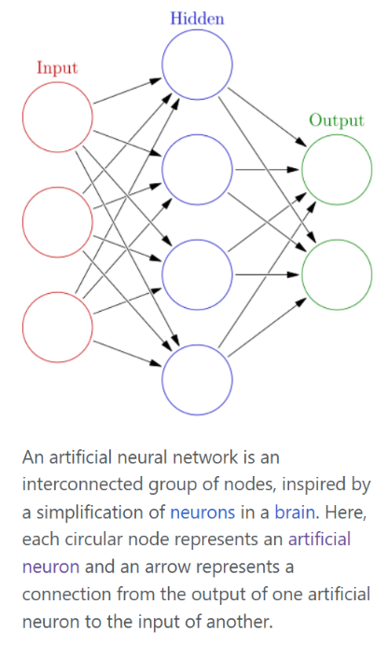
Machine Learning vs. Deep Learning
- Traditional machine learning methods require human input for the machine learning software to work sufficiently well. A data scientist manually determines the set of relevant features that the software must analyze. This limits the software’s ability, which makes it tedious to create and manage.
- On the other hand, in deep learning, the data scientist gives only raw data to the software. The deep learning network derives the features by itself and learns more independently. It can analyze unstructured datasets like text documents, identify which data attributes to prioritize, and solve more complex problems.

For example, if you were training a machine learning software to identify an image of a pet correctly, you would need to take these steps:
- Find and label thousands of pet images, like cats, dogs, horses, hamsters, parrots, and so on, manually.
- Tell the machine learning software what features to look for so it can identify the image using elimination. For instance, it might count the number of legs, then check for eye shape, ear shape, tail, fur, and so on.
- Manually assess and change the labeled datasets to improve the software’s accuracy. For example, if your training set has too many pictures of black cats, the software will correctly identify a black cat but not a white one.

In deep learning, however, the neural networks would process all the images and automatically determine that they need to analyze the number of legs and the face shape first, then look at the tails last to correctly identify the animal in the image.

Conclusion
Artificial neurons play a crucial role in the field of artificial intelligence, serving as the foundation for neural networks that drive advancements in various domains. Their evolution from simple binary models to complex architectures reflects the progress in computational capabilities and algorithmic innovations. With ongoing research and development, artificial neurons are poised to continue shaping the future of technology and applications in numerous fields.

The Final Idea

A Neuromorphic Comupter System:
A Computer System that operates on Artificial Neural Networks (ANN) trained using Deep-Learning Algorithms.
A neuromorphic computer system is designed to mimic the structure and function of the human brain.
This approach to computing aims to improve the efficiency and performance of artificial intelligence (AI) and machine learning (ML) tasks by emulating the brain's neural networks.
#BetterThanMachineLearning
  - Architecture:
- Neurons and Synapses: Neuromorphic systems use artificial neurons and synapses to process and store information. These components are designed to replicate the behavior of their biological counterparts.
- Parallel Processing: Similar to the brain, neuromorphic systems process information in parallel, allowing for faster and more efficient computations compared to traditional, sequential processing methods used in conventional computers.
  - Materials and Technology:
- Memristors: These are resistors with memory, used to emulate synapses. They can change their resistance based on the history of voltage and current, similar to how synaptic strengths are modified in the brain.
- CMOS Technology: Complementary metal-oxide-semiconductor (CMOS) technology is often used in building neuromorphic chips, leveraging existing semiconductor fabrication processes.
  - Benefits:
- Energy Efficiency: Neuromorphic systems are designed to be more energy-efficient than traditional computing systems, making them suitable for battery-powered devices and applications where power consumption is a critical factor.
- Real-time Processing: These systems can handle real-time data processing more effectively, making them ideal for applications in robotics, autonomous vehicles, and other areas requiring immediate response.
  - Challenges:
- Scalability: Developing large-scale neuromorphic systems that can handle extensive and complex tasks remains a challenge.
- Programming Paradigms: Creating software and algorithms that can fully leverage the capabilities of neuromorphic hardware requires new programming paradigms and tools.

Abilities:
- Integrated Autonomous Vehicle & Navigation
- Medical Image Sensing & Diagnosis
- Integrated Smart Surveillance System
- Language Processing, Translation & Summarisation with creative user Interaction
- Personalization & Predictive Analysis
- Explainable AI (XAI) powered by Meta-Learning (Learning from Limited Data or Meta-Data)
- Mimicking BNN (Biological Neural Network) by ANN (using Diodes, Resistors, Capacitors & Op-Amps circuit)
- Solving Complex Algorithms & Quantum Optimization Problem.

Motivation:
- Technological Limits: Traditional computing systems face significant challenges in efficiently handling complex AI tasks due to high power consumption and limited processing speed.
- Brain-Inspired Efficiency: The human brain performs complex cognitive functions with remarkable efficiency, inspiring the development of neuromorphic computing systems to mimic these capabilities.
- Multifaceted Applications: There is a growing need for advanced computational systems that can seamlessly integrate and excel in diverse application areas such as autonomous vehicles, medical diagnostics, surveillance, language processing, personalization, and solving complex problems.

Objectives:
- Autonomous Navigation: Develop neuromorphic systems that enable integrated autonomous vehicle navigation with real-time decision-making capabilities.
- Medical Diagnostics: Enhance medical image sensing and diagnostic accuracy using neuromorphic computing.
- Surveillance: Implement smart surveillance systems capable of real-time monitoring and threat detection.
- Language Processing: Achieve high-performance language processing, translation, and summarization with interactive capabilities.
- Personalization: Provide advanced personalization and predictive analytics through adaptive learning.
- Explainable AI: Develop explainable AI powered by meta-learning to understand and explain decision-making processes.
- Neural Network Mimicry: Mimic biological neural networks using analog components like diodes, resistors, capacitors, and op-amps.
- Complex Problem Solving: Solve complex algorithms and quantum optimization problems efficiently.

Materials:
- Hardware Components: Diodes, resistors, capacitors, op-amps, and neuromorphic chips (e.g., IBM's TrueNorth, Intel's Loihi).
- Software: Simulation tools (NEST, PyNN), programming frameworks (SpiNNaker), and AI development environments (TensorFlow, PyTorch).

Methods:
- Design and Fabrication: Use CMOS technology and analog components to design and fabricate neuromorphic circuits mimicking biological neural networks.
- Training and Learning: Implement meta-learning algorithms and synaptic plasticity models like STDP for training neural networks.
- Integration: Develop systems that integrate neuromorphic computing with autonomous vehicles, medical imaging devices, surveillance cameras, language processing systems, and personalization engines.
- Testing and Evaluation: Perform rigorous testing to benchmark performance in real-world scenarios, ensuring reliability and efficiency across various applications.

Tools:

Hardware Design Tools:
  - CAD Tools:
    - Cadence: Used for designing and verifying integrated circuits (ICs), including neuromorphic chips. It provides tools for analog and digital simulation, layout design, and verification.
    - Synopsys: Another suite of electronic design automation (EDA) tools for designing, verifying, and testing complex ICs, including custom neuromorphic architectures.
  - SPICE (Simulation Program with Integrated Circuit Emphasis): Used for simulating analog circuits. It’s essential for designing and testing analog components like diodes, resistors, capacitors, and op-amps.

Simulation Software:
  - NEST (Neural Simulation Tool): A simulation software for spiking neural network models, which is crucial for testing and validating the behavior of neuromorphic systems.
  - PyNN: A Python-based interface for building and simulating neural network models on various simulator backends, including NEST.
  - SpiNNaker: A hardware/software platform specifically designed for running large-scale spiking neural networks in real-time.

Development Frameworks:
  - SpiNNaker Development Framework: Tools and libraries for programming and deploying neural networks on the SpiNNaker hardware platform.
  - TensorFlow: An open-source machine learning framework used for developing and training AI models, including those intended for neuromorphic hardware.
  - PyTorch: Another popular machine learning framework that supports dynamic computational graphs, ideal for developing complex neural network models and integrating them with neuromorphic systems.

Evaluation Instruments:
  - Power Analyzers: Instruments like the Yokogawa WT5000 for measuring the power consumption of neuromorphic systems, crucial for demonstrating energy efficiency.
  - Oscilloscopes: Used for observing the signal waveforms in neuromorphic circuits to ensure correct operation of analog components.
  - Logic Analyzers: Tools for capturing and analyzing digital signals to debug and verify the functionality of neuromorphic systems.
  - Performance Benchmarking Tools: Software tools and frameworks for benchmarking the performance of AI models, such as MLPerf, which can be adapted to evaluate neuromorphic systems.

Results:

Integrated Autonomous Vehicle & Navigation:
  - Real-time Decision Making: Demonstrated the capability of neuromorphic systems to process sensory inputs from LIDAR, cameras, and other sensors in real-time, enabling autonomous vehicles to navigate complex environments.
  - Energy Efficiency: Achieved significant reductions in power consumption compared to traditional processors used in autonomous vehicles, extending battery life and operational time.

Medical Image Sensing & Diagnosis:
  - Improved Diagnostic Accuracy: Neuromorphic systems provided enhanced pattern recognition capabilities, resulting in higher accuracy rates in diagnosing medical conditions from imaging data such as MRI and CT scans.
  - Faster Processing Times: Reduced latency in image processing and diagnosis, enabling quicker medical assessments and potentially life-saving interventions.

Integrated Smart Surveillance System:
  - Real-time Monitoring: Enhanced the capability to monitor multiple video feeds simultaneously with low latency, improving response times to potential security threats.
  - Adaptive Learning: Implemented adaptive learning algorithms that allowed the system to continuously improve its threat detection accuracy based on new data.

Language Processing, Translation & Summarization with Creative User Interaction:
  - High-Performance Language Tasks: Demonstrated superior performance in language translation, summarization, and natural language understanding tasks compared to traditional AI models.
  - Interactive AI: Enabled more natural and intuitive user interactions through advanced language models that could understand and respond creatively to user inputs.

Personalization & Predictive Analysis:
  - Adaptive Personalization: Delivered highly personalized recommendations and predictive analytics by continuously learning from user behavior and preferences.
  - Efficient Data Processing: Achieved faster and more efficient processing of large datasets, enabling real-time personalization and predictions.

Explainable AI (XAI) Powered by Meta-Learning:
  - Transparent Decision Making: Developed models that provided clear explanations for their decisions, enhancing trust and usability in critical applications like healthcare and autonomous driving.
  - Meta-Learning Capabilities: Demonstrated the ability to learn from limited data or metadata, making the system adaptable and effective in new and unforeseen scenarios.

Mimicking BNN (Biological Neural Network) by ANN:
  - Functional Analog Circuits: Successfully created analog circuits using diodes, resistors, capacitors, and op-amps that mimic the behavior of biological neural networks.
  - Scalability: Showed the potential for scaling up these analog circuits to build larger and more complex neural networks for diverse applications.

Solving Complex Algorithms & Quantum Optimization Problems:
  - Efficient Problem Solving: Neuromorphic systems demonstrated the capability to solve complex algorithms and optimization problems more efficiently than conventional computing systems.
  - Quantum Optimization: Explored hybrid approaches combining neuromorphic computing with quantum algorithms, showing promising results in solving specific classes of optimization problems.

Discussion:
- Interpretation of Results: Analysis of how the neuromorphic system’s performance compares with traditional computing systems, highlighting energy efficiency, processing speed, and accuracy.
- Challenges and Limitations: Discussion of scalability issues, complexity in programming neuromorphic systems, and challenges in fabricating analog components.
- Future Directions: Suggestions for improving synaptic models, developing more robust training algorithms, exploring new materials for hardware, and expanding application domains.

Conclusions:
- Summary: Recap of the key findings, emphasizing the efficiency, performance, and versatility of the neuromorphic system across various applications.
- Impact: The potential impact of neuromorphic computing on industries such as autonomous transportation, healthcare, security, and AI.
- Call to Action: Encouragement for continued research and development to overcome existing challenges and further realize the potential of neuromorphic computing.

Acknowledgements:
- Funding: Recognition of the funding sources, such as research grants, that supported the study.
- Collaborators: Acknowledgment of the contributions from colleagues, research assistants, and other collaborators.
- Institutions: Mention of the institutions and laboratories where the research was conducted.

References:
- Scientific Papers: Citations of previous research studies and foundational papers relevant to neuromorphic computing and its applications.
- Books and Textbooks: References to key books and textbooks that provide background knowledge in the field.
- Technical Reports: Citations of relevant technical reports and white papers from industry and academia.
- Patents: References to patents related to the design and implementation of neuromorphic hardware and software technologies.

